Thinking allowed

Our world is becoming more complex and unpredictable. Big Data and AI are overwhelming our ability to think. Thinking allowed has been designed to re-invigorate the quality of discourse and debate for boards and senior executives.

The programme leaders are futurologist Richard Watson (Imperial College, London Business School); philosopher Professor Roger Steare (Cass Business School, FTIE Corporate Learning Alliance, Duke Corporate Education); and strategist Nick Turner (Morgan Stanley, Imperial College, London Business School, INSEAD).

Thinking allowed is a 24-hour retreat from the non-stop noise of working life and the devices that deliver and amplify this assault. It is an opportunity for groups of senior executives to:

- Create a safe space for deep, open and honest reflection and debate
- Deepen emotional engagement, trust and a sense of community
- Build confidence to accept challenge and diversity of thought
- Explore the unvarnished present along with probable and possible futures
- Challenge “sacred cows” and “official futures”
- Escape the “urgent” and focus on the “important”
- Re-think how leaders think both together and alone
- Be systems thinkers, not just analysts and determinists
- Explore shared purpose, moral values and simple rules in decision-making
- Discover and develop new thinking tools
- Build capability on how to shape and achieve successful futures
- Learn how to coach and lead better thinking with their own teams
- Plan ongoing engagement and support as a community of learners

Thinking allowed takes place at “unplugged” venues that are different such as a boat, a train or an island. The agenda, which is designed to be tailored, flexible and adaptive, will often be structured like this:

- Pre-work: “What’s on my mind?”, card sort exercise
- Day 0. Evening session: The learning experience begins with drinks and dinner where everyone is encouraged to get to know each other well enough to develop a truly open, safe and honest debate the following day
- Day 1. Session 1: Richard will give a ‘big picture’ overview of mega-trends and technologies and then explain why such linear thinking can and does go wrong
- Session 2: Roger will lead an exploration of social purpose, values and simple rules for debate and decision-making; followed by an introduction to systems thinking
- Early lunch
- Session 3: Nick will facilitate the creation of different scenarios to envision how the future may actually unfold (what if?), the key implications for your organisation (so what?) and the strategic options (what next?).
- Session 4: Richard, Roger and Nick will work with executives in three smaller groups, to think through and debate the big decisions they must make
- Session 5: Leaders will think through and debate how they will continue to learn, practice and coach others

Who is Roger Steare?

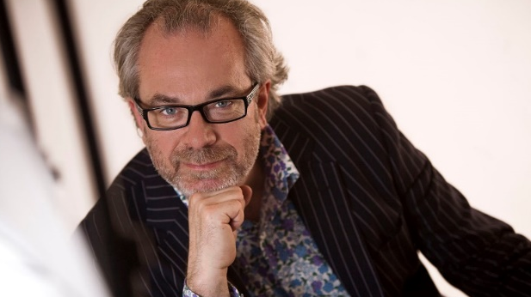
Roger Steare really is a “son of a preacher man”. He grew up listening to his father’s sermons in Methodist chapels where his family would often double the size of the congregation. From learning about Christian ethics, Roger studied philosophy at London University with Conrad Russell, son of the great British philosopher, Bertrand Russell. After graduation he joined Midland Bank in the City but left after two years of boredom. He then became a Residential Social Worker caring for wayward children from deprived London boroughs.

Since 2002, Roger has become internationally recognised as one of the leading experts advising the Boards and executive teams on building high performing, high integrity organisations. Roger’s work with BP after the Gulf of Mexico disaster has been crucial to the company’s recovery plan.

Roger has advised Barclays, HSBC, Lloyds Bank and RBS after the credit crisis, PPI and Libor, with his work publicly endorsed by the Financial Conduct Authority. His most recent assignment has been with Nationwide Building Society where he has supported the senior executive team in achieving not only the Which? Banking Brand of the Year 2017, but also the largest winner of banking current account switchers, regularly out-scoring all major banking competitors combined.

Roger has worked with clients to achieve these results by basing his guidance on the evidence of best-practice across all sectors from around the world. He has conducted extensive empirical research on both personal and professional integrity, with his MoralDNA Profile cited in papers published by the Chartered Management Institute, the Chartered Insurance Institute, EY, the FCA and PWC.

His book ethicability has sold over 25,000 copies and has been licensed as an e-book to over 600,000 employees across the firms he advises. Roger is Professor of Organisational Ethics and Corporate Philosopher in Residence at Cass Business School. He also teaches at Duke Corporate Education, FTIE Corporate Learning Alliance and London Business School.

What others think of Roger…

“Roger has helped me consider business decisions from a fresh perspective. His approach might be rooted in philosophy, but in reality, it is about pragmatic, profitable yet principled management of a business for long term success.”
Joe Garner, CEO, Nationwide Building Society

“It was great to listen to you. The panel and especially your interventions were the most thought provoking and simulating I have heard in a long time. Glad I signed up to the conference.”
Arlene McCarthy OBE, Special Advisor to Michael Bloomberg

“We’ve had nothing but extremely positive feedback from delegates, who enjoyed your insight, humour, energy, perspective, challenge and care.”
David Morris, Chief Learning Officer, HSBC
Who is Nick Turner?

A convener, facilitator and provocateur of strategic conversations, Nick Turner is an advisor, strategist and futures thinker. He has over 25 years’ experience working with the top teams of the world’s leading organisations, helping make better choices today for an uncertain tomorrow.

Nick founded Stratforma as a strategic advisory boutique and has since led a diverse range of strategy formulation and capability building initiatives, across multiple geographies and sectors, including banking, asset management, energy, technology, media and telecommunications.

Formerly a product of Silicon Valley and Wall Street, Nick served as a Managing Director at both Morgan Stanley and Nomura, after a number of years spent in the high-technology industry, in Europe and California. As a strategy consultant, Nick was the Co-President of scenario planning pioneers Global Business Network (GBN) and a Senior Partner of Michael Porter’s Monitor Group.

Recent clients have included Bank of America, Barclays, BlackRock, BP, Citigroup, Coutts, Crédit Agricole, DMGT, Fidelity International, McLaren Applied Technologies, RBS, Santander and Thomson Reuters.

A compelling speaker and world-class facilitator, Nick has shared his experience and expertise in a variety of settings. He has designed and led customised executive development programmes and is a guest lecturer at leading universities and business schools, including London Business School (LBS), Imperial College Business School, and INSEAD.

What others think of Nick…

“Once again, thank you for making this event such an outstanding success.”
Head of Capital Markets, Global Investment Bank

“..the interactive scenario workshop was very helpful to stimulate the participants to approach the future in a very structured way. The way you led the workshop was very professional but with enough humour to keep people sharp..”
Managing Director of Investments, European Pension Fund

“We are hugely indebted to you for the superb job you did in facilitating the Panel’s annual meeting. You kept us focused, on track and completely engaged throughout. And of course you did it with immense style and wit.”
Chairman, National Employment Panel

“We were impressed with your contribution and thought you would be please to know that the segment received terrific feedback.”
President, China Institute

Who is Richard Watson?

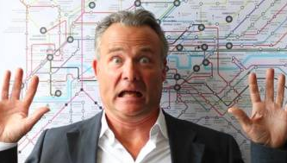
Richard read politics with economics and philosophy at university while working as a dishwasher in a local bistro. It’s debatable which proved more educational or contained the most politics.

After a decade meandering through advertising and design, Richard ended up writing about innovation for Fast Company magazine in the 1990s, which was the catalyst for setting up one of the first innovation agencies. However, this proved too innovative at the time and while fascinating projects emerged (e.g. ethics for Big Tobacco) he ended up in Sydney writing about the trends underpinning innovation. This morphed into the What’s Next report, which endured for 14 years.

These days Richard is Futurist-in-Residence at the Technology Foresight Practice at Imperial College London. He is also a lecturer at London Business School and a member of the Civil Aviation Authority’s (CAAs) Aviation Futures Group.

Richard has worked with, amongst others, Cambridge University, McKinsey, Lego, Ikea, the Royal College of Art, RAND corporation, Shell, the Cabinet Office, the Ministry of Defence, the Department of Education, PWC, IBM, Vodafone, the King’s Fund and the NHS.

Richard has written five books. His first, Future Files (2007), was translated into sixteen languages. His latest, Digital Vs. Human, explores the race to remain human in light of artificial intelligence, robotics and the internet.

When he’s not thinking, Richard likes old cars, old calvados (Armagnac or Rhone reds if you really must) and the hopeless optimism associated with gardening in the English climate.

What others think of Richard…

“What a wonderful speaker you are – passionate, funny and insightful – we were blown away by your talk”
Executive Director, SCONUL

“A class act”
Head of Learning & Development, Lloyds Insurance

“Thank goodness there are people like you in the world... you make everyone think!”
President, ESP TrendLab, New York

“I liked the emphasis on deep thinking and making time for it; very entertaining speaker and topic was interesting.”
Welsh, Carson, Anderson & Stowe, New York

“’I could have listened all day’ to ‘It blew my mind.’ Thank you for providing what proved to be a memorable and thought-provoking talk…”
Travelers Europe

